UoLSoCS Work In Progress Template (Note Initial Capital Letters)

*Please do not modify this text block unless you receive explicit instructions.*

*CMP3753M Project*,

Proposal/Work in Progress Document.

Grateful thanks goes to the ACMSIGCHI Extended Abstracts format on which this is based. <https://sigchi.github.io/Document-Formats/>

# Abstract

Author

University of Lincoln

School of Computer Science

author@students.lincoln.ac.uk

This sample paper describes the formatting requirements for the CMP3753M Project Work in Progress format. This sample file offers recommendations on writing for wider readership. Please review this document to see the requirements for the WiP document. Abstracts should be about 75-100 words and are required. They should summarise your proposal and should really inform the reader of your project and its goals.

# Author Keywords

Authors’ choice; of terms; separated; by semicolons; include commas, within terms only; required. Have a look at <https://www.acm.org/publications/class-2012> for examples of keywords to describe your project. Eg:

Co-Viewing, TV, Twitter, Social Media

# Introduction

This format is to be used for submissions that you make for CMP3753M Assessment 1: Project Work in Progress. We wish to give this paper a consistent, high-quality appearance. We therefore ask that you follow some simple guidelines. In essence, you should format your paper exactly like this document. The easiest way to do this is to replace the content with your own material.

# Page Size

# Good Utilization of the Side Bar

**Preparation**: Do not change the text box size or position. Do copy text box to other pages. You may change the surrounding box to be visible or invisible, up to you.

**Materials:** This cannot appear higher or lower on the page because of pagination and specific headers added during the indexing and pagination process. A 0.75 inch rule is beneficial to break this apart from the body text. The text in this text box should remain the same size as the Body Text: 8.5 Verdana or Arial (with use of **bold** and *italics* to highlight points)

**Images & Figures:** Images and figures can be placed in this section. They should be captioned in the manner of other images and figures.

The CMP3753M Assessment 1 submission should be US letter (8.5x11 inches) and not A4. US Letter is a standard option on all versions of Microsoft Word, as well as most other document preparation programs.

# Text Formatting

Please use an 8.5-point Verdana font, or other sans serifs font as close as possible in appearance to Verdana in which these guidelines have been set. (The “Normal” style for this document automatically gives you this font setting.) Arial 9-point font is a reasonable substitute for Verdana as it has a similar x-height. Please use serif or non-proportional fonts only for special purposes, such as distinguishing source code text.

## Text styles

The template uses MS Word text styles to facilitate text formatting, and we highly recommend you use these Styles instead of manually applying formatting. The applicable text styles are:

* Normal—for body text. Don’t use “Default Paragraph Font”.
* Heading 1, Heading 2, Heading 3
* Bullet list
* Numbered list
* Caption
* References—for bibliographic entries

Additionally, here is an example of footnoted text.[1] (The footnote is created with the “footnote…” command under the “References” menu in MS Word). As stated in the footnote, footnotes should rarely be used.

## Quotes

Quotes may be italicized and“placed inline”(Smith, 2016).

Longer quotes, when placed in their own paragraph, need not be italicized or in quotation marks. (Jones, 2018).

## Figures

The examples on these pages should help you get a feel for how figures should be placed in the template. *Be sure to make images large enough so the important details are legible and clear.* Your document may use colour figures, which are included in the page limit; the figures *must* be legible and usable when printed in black and white. If you aren’t familiar with Word’s handling of pictures, we offer one tip: placing images and their captions in text boxes can be useful to control the position of pictures and the flow of text around them. We recommend using Photoshop or other graphics software to scale images, rather than scaling them after you have placed them in Word. Figure 3 shows a treatment of large figures, too big to fit inside a single column of text. All figures should include alt text for improved accessibility. In Word, right click the figure, and select Edit Alt Text).

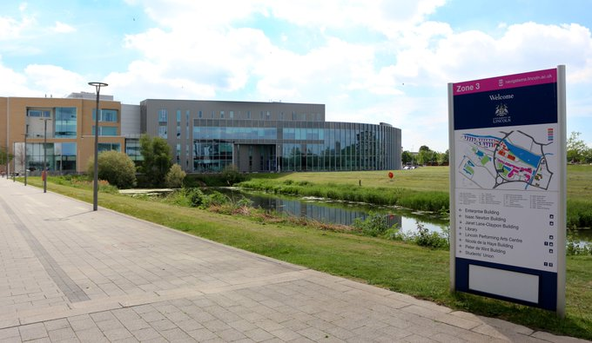

**Figure 1**: Insert a caption below each figure. We suggest selecting the image and then using Insert, Caption. Make sure you use the Caption style for text formatting. All 1-line captions should be centred; justify longer captions.

## Tables

Tables should be clearly formatted, and may be as wide as the two text columns. Large tables should be placed in a Text Box for easier formatting control, similar to large images.

|  |  |  |  |
| --- | --- | --- | --- |
| Name | First | Second | Last |
| Marsden | 223.0 | 44 | 432,321 |
| Nass | 22.2 | 16 | 234,333 |
| Borriello | 22.9 | 11 | 93,123 |
| Karat | 34.9 | 2200 | 103,322 |

**Table 1**. Table captions should be below the table. We recommend table lines be 1pt, 75% brightness grey. Minimize use of unnecessary table lines. For larger tables, consider banded rows (select table, then click Tables, Banded Rows) to guide the eye.

For improved accessibility, header rows of tables should be marked. In Word, right-click a selected header row, and select Table Properties | Row | Repeat as header row at the top of each page. All tables should include alt text for accessibility.

# Language, style, and content

**Figure 2** You can save space by placing images in the sidebar. Images should have captions and be within the boundaries of the text box on Page 2.

Please only use the UK dialect of English in your document. For example, use ‘colour’ instead of ‘color’. Make sure that, for example, Word is using English (United Kingdom) rather than English (United States). Hyphenation is optional. Please follow the following language guidelines:

* Write in a straightforward style. Try to avoid long sentences and complex sentence structures. Use semicolons carefully.
* Use common and basic vocabulary (e.g., use the word “unusual” rather than the word “arcane”).
* Briefly define or explain all technical terms. The terminology common to your practice/discipline may be different in other design practices/disciplines.
* Explain all acronyms the first time they are used in your text—e.g., “Digital Signal Processing (DSP)”.
* Explain “insider” comments. Ensure that your whole audience understands any reference whose meaning you do not describe (e.g., do not assume that everyone has used an Android phone or a particular application).
* Be careful with the use of gender-specific pronouns (*he*, *she*) and other gendered words (*chairman*, *manpower*, *man-months*). Use inclusive language that is gender-neutral (e.g., *she* *or* *he*, *they*, *s/he*, *chair*, *staff*, *staff-hours*, *person-years*).

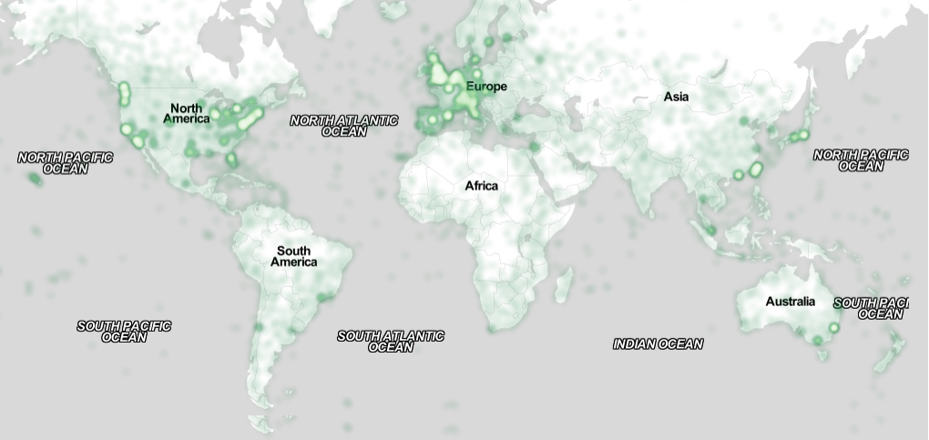

**Figure 3.** You can make figures as wide as you need, up to a maximum of the full width of both columns. To achieve this, create a text box using Insert | Text Box and resize it to the full width. Image CC-BY-ND ayman on Flickr.

So long as you don’t type outside the margins, it’s okay to put annotations over here, too.

|  |  |  |
| --- | --- | --- |
|  | First | Location |
| Child | 22.5 | Melbourne |
| Adult | 22.0 | Bogotá |
| Gene | 22.0 | Palo Alto |
| John | 34.5 | Minneapolis |

**Table 2.** A sample narrow table in the margin.

# Producing and Testing PDF Files

We recommend that you produce a PDF version of your submission well before the final submission deadline.

Test your PDF file by viewing or printing it with, for example, Adobe Acrobat Reader Version 10, which is widely available.

# Acknowledgements

Grateful thanks to all the volunteers, publications support, staff, and authors at SIGCHI who wrote the original version of this document. This whole paragraph is just for example. Some of the references cited in this paper are included for illustrative purposes only.

# References format

Your references should in the University of Lincoln Harvard format (University of Lincoln, 2019).

You need to reference to demonstrate you have undertaken the research, to ensure that the information sources you have referred to can be found, to give your marker the opportunity to consider the reliability and suitability of your sources, and to avoid plagiarism.

References *must* be the same font size as other body text. References should be in alphabetical order by last name of first author.

The references shown are examples.

# References

@_CHINOSAUR (2014) VENUE IS TOO COLD. #BINGO #CHI2016 [Twitter]. 1 May, 2016. Available from https://twitter.com/_CHINOSAUR [accessed September 10, 2019]

ACM. *How to Classify Works Using ACM’s Computing Classification System. 2014.* Available from <http://www.acm.org/class/how_to_use.html> [Accessed August 22, 2019]

Anderson, R. (1992) Social impacts of computing: Codes of professional ethics. *Soc Sci Comput Rev 10, 2: 453-469.*

Cavender, A., Trewin, S. and Hanson, V. (2014). *Accessible Writing Guide.* Available from http://www.sigaccess.org/welcome-to-sigaccess/resources/accessible-writing-guide/ [accessed August 22, 2019]

Heilig, M. 1962. *Sensorama Simulator*, U.S. Patent 3,050,870, Filed January 10, 1961, issued August 28, 1962.

Kaye, J. and Dourish, P. (2014) Special issue on science fiction and ubiquitous computing. *Personal Ubiquitous Comput*. 18, 4 (April 2014), 765-766.

Klemmer, S., Thomsen, M., Phelps-Goodman, E., Lee, R. and Landay, J. (2002) Where do web sites come from?: capturing and interacting with design history. In *Proceedings of the SIGCHI Conference on Human Factors in Computing Systems* (CHI '02), 1-8.

Nintendo R&D1 and Intelligent Systems (1994) *Super Metroid* [game, SNES]. (18 April 1994). Nintendo, Kyoto, Japan. Played August 2019.

Psy (2012) *Gangnam Style*. [video] Available from <https://www.youtube.com/watch?v=9bZkp7q19f0> [accessed August 22, 2019]

Schwartz, M. (1995) *Guidelines for Bias-Free Writing.* Indiana University Press, Bloomington, IN.

Sutherland, I. (1963) *Sketchpad, a Man-Machine Graphical Communication System*. Ph.D. Dissertation. Massachusetts Institute of Technology (MIT), Cambridge, MA.

University of Lincoln (2019) *Referencing* Available from <https://guides.library.lincoln.ac.uk/learn/referencing> [accessed September 10, 2019]

Winner, L. (1999) Do artifacts have politics? In D. Mackenzie and J Waicman (eds) *The Social Shaping of Technology* (2nd. ed.) Open University Press, Buckingham, UK, 28-40.

1. Use footnotes sparingly, if at all.